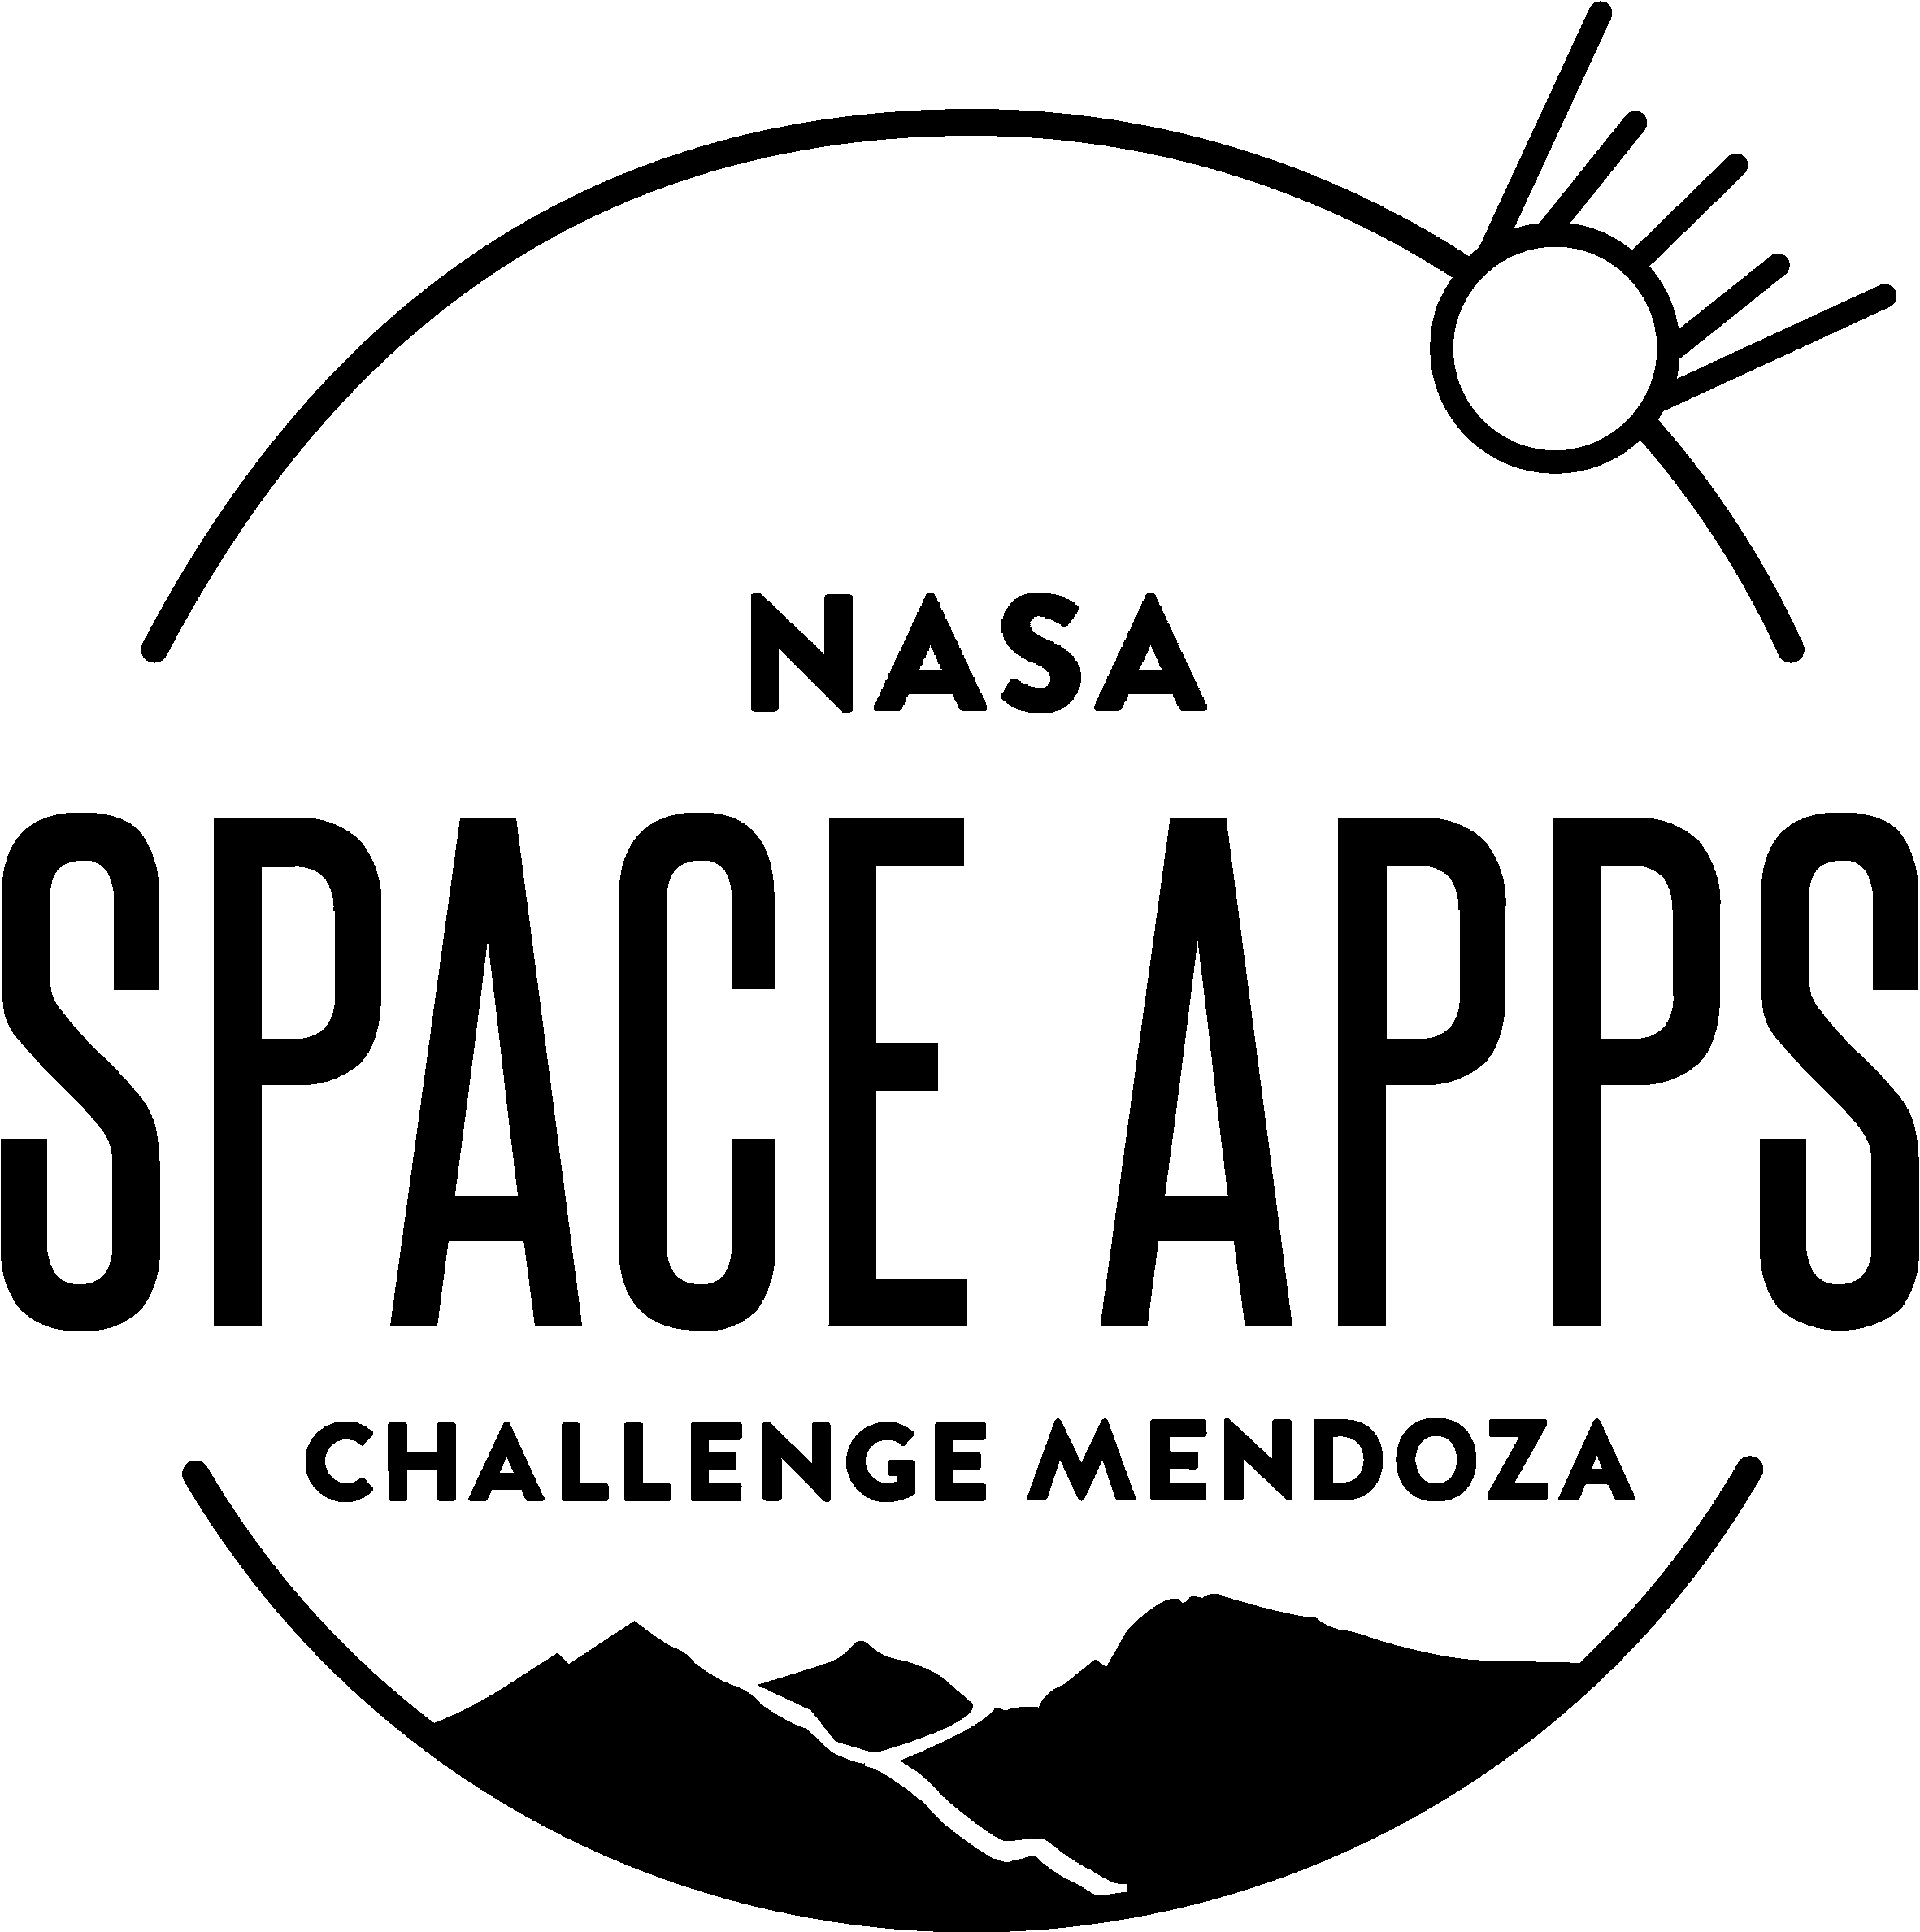

U-Sat: From outer space to your fingertips

The challenge we chose is “Set your sights high!” While it may not be the most groundbreaking one, we do believe that it can help, inspire and aid people whether it is just to fulfill one’s natural curiosity or to help make an informed decision. U-Sat is unique because it is intuitive and it’s main goal is to be useful and educational.

Problem:

Information is being gathered every second all around us, satellites fly over our heads several times a day. What they collect, who, and how can it be useful are questions not so easily answered. The problem we are trying to solve is how difficult it is for the people without technical formation to have access and make use of information available on satellites. Different tech companies own these helpful machines and while the orbit is easy to access, the Intel they collect isn’t, all the available info is rare and scattered all over the internet.

Solution:

“Scientia potentia est”

Knowledge is power someone once said and our group set the bases for solving our challenge in this belief. We think everyday people can actually make good use of the data that is globally collected 24/7. What we do is gather and simplify the information so that the general public can take advantage from it. So we embarked on the journey of making the app and digging up every piece of information we could find.

Anybody can use the information to know how the weather is, or the wind currents at someplace they plan to visit. But just how amazing can it be to have it all in just one place? One where you inform yourself, where you can have tailored the information you want, where you can learn.

U-Sat can be a great tool for those interested in the environment as you can visualize multiple environmental parameters such as temperature, humidity, height of vegetation and wind speed.

Uses & applications:

It is possible to make predictions with the information. It is also possible to use for educational purposes. And can be used to improve the production on some type of business.

The technology and Science behind it:

We investigated how the telemetry that is used on the communication with the satellites works, so that we know how much time takes to gather the information. Basic knowledge of orbital mechanics was also needed to calculate the orbits of the satellites and their journey.

We investigate a form to analyze the raw images that the satellites gather, that use different equations with the number of colours that the image has.

The app was made using “appinventor” which is a development software for android apps, we found it very useful for our project because is very simple and easy to understand.

We also used “Blender” for making our own 3D models of the earth and the orbits of the satellites.

Facing the future head on:

Looking into the future we have some ideas for the app.

We think one of the best ways to show the information in the app is with the use of channels with different information so the user looks only for what they are interested in. Moving forward with this idea we can implement notification about the satellites that are flying over your head in real time and show the information that it has gathered.

The idea is to create a database with all the public information that the satellites collect (that has to be translated into numbers first) and simplify it so that the user, with no formation on this area, can read and make use out of it.

We searched about the use of the information and we found about the application on farming. The owners of largue extensions of land can monitor their properties and see comparisons in different periods of time about the fertility of the land or how much they took to grow crops, how they can maximize the use of the space that they have.

Sometime in the future we would like to add a few minigames to add variety if possible. The other option is to create a separate app so to engage children too, and spark their interest early on.

How we got and developed the idea:

At first we were trying to create an app to look into the information of the satellites and we hit a wall, because all of the information is either private, difficult to understand, or make little to no sense (at least for everyday people, like us). We search for similar apps to the one we wanted to create and discovered a few of them, like the “Earth Now” from NASA (which inspired us). This app shows some information about the satellites that could be in fact useful but difficult to understand. Because we didn’t want to make the same mistake, our focus is in the user whether it is a highschool kid, to the owner of a vineyard, or someone passionate about the environment.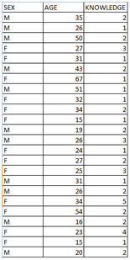

We decided to start asking around about what knowledge they have about and wished to know of the satellites and the info that they gather, we made a survey and these were the results.

As you can see in the image on the right, there are many people that don’t know anything about satellites and their uses.

This gave us the purpose to make the app, so all the people that don’t know can learn about the satellites.

Into the app:

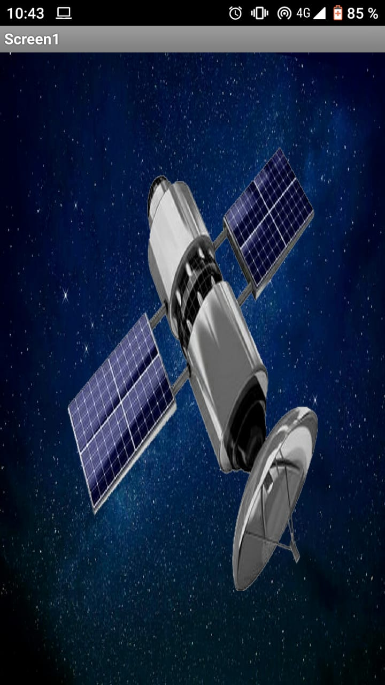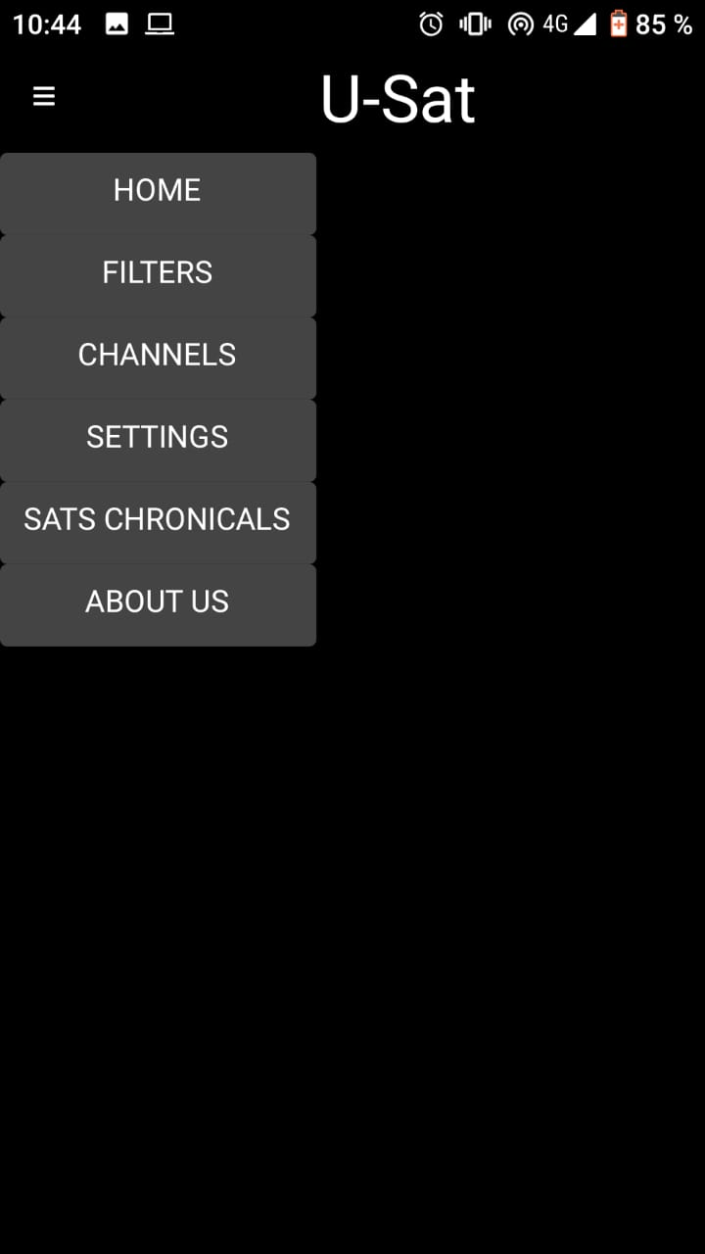

-Home and

This is the homescreen of our app, here you can see a 3D model of the earth with the satellites in their own orbits around the earth, you can touch the satellites to see a 3D model of them and some information about the different measurement equipment that they have installed. In the left corner to the top you have a menu with different options.

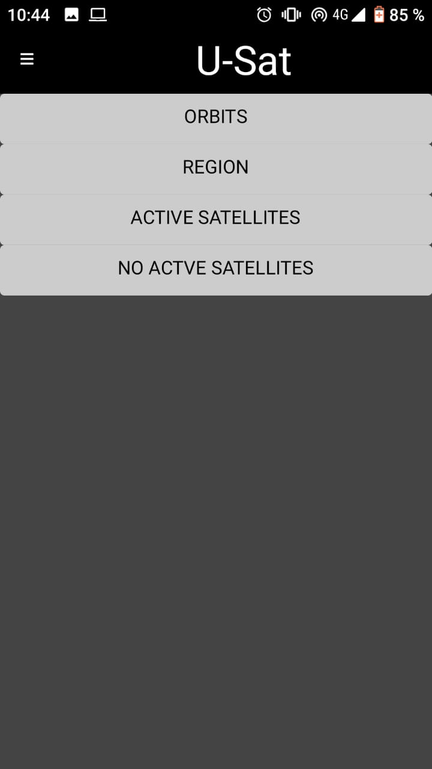

<-Filters

In this page you can change what is showing in the 3D model like the different orbits or the region you want to look at. It is possible to filter out and choose what you want to look at or don’t.

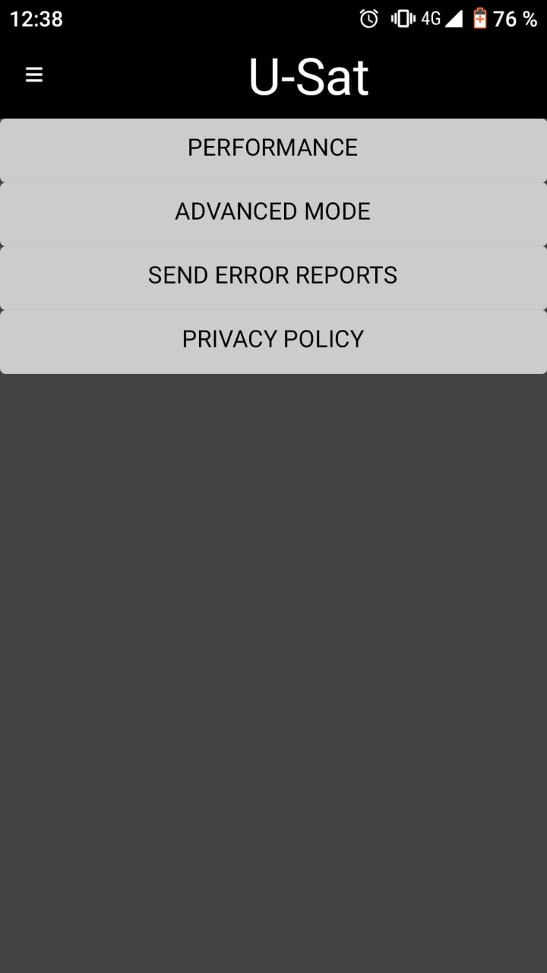

<-Settings

Here you can make changes to the app like the performance or the looks.

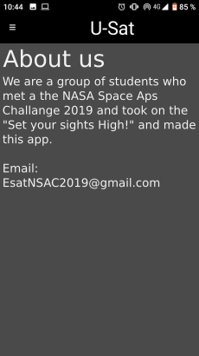

<-About us

Here you have a description about how the project started and ways to communicate with us so you can give us your feedback. We are willing to improve and your help is welcome!

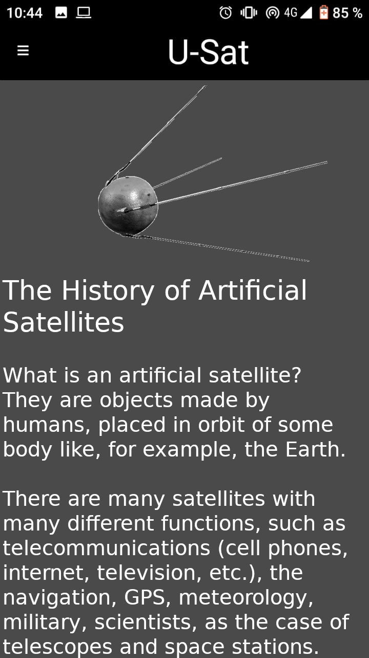

<-Satellites chronicles

In here you can read information about the first satellites, some fun facts and have a look at the history behind them.

Conclusion:

When we first started this challenge for the Space Apps Challenge 2019 we had little to no knowledge about satellites. As we moved forward we found out that in fact we knew almost nothing, and with an app like “Space Now” out there this challenge seemed pointless. However, we saw a missing (and vital) part to all of this. What is information if there is nothing you can make out of it? If it’s inaccessible? We decided to change that, in the 21st century when we are more connected than ever and you can find anything on the internet, unawareness is still an issue. We truly hope that our project can inspire other people whether it is to learn, educate others, or to get up from their chair and make a change. We wish to have been successful in transmitting the same inspiration we felt and the people from Nasa and Mars Society Argentina transmitted us.

Ultimately, we hope that this app will shade some light into a subject that may not be clear for everyone and also to inspire anyone who uses it. Knowledge is to be shared and it can help us improve for the best.

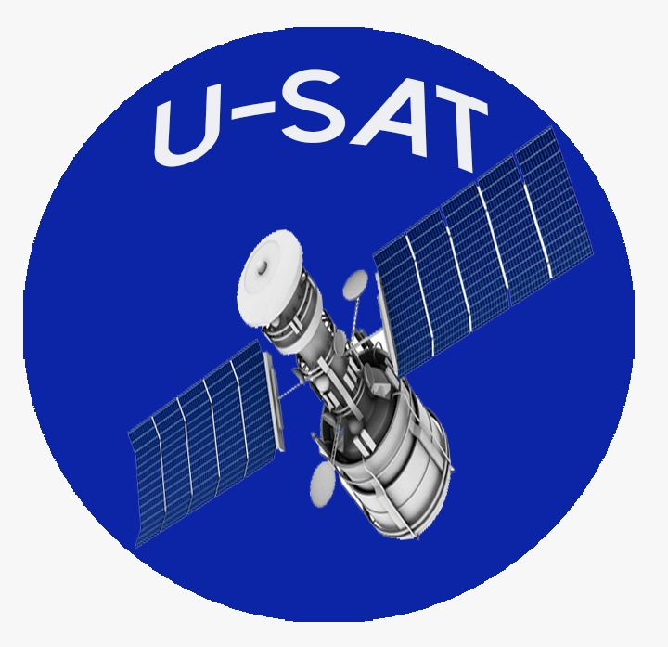

Thank you,

U-Sat.

(Alejo Zanni, Franco Fonollá, Francesco Gentile, Máximo Miranda, Maitén Oviedo, Yael Gajardo.)